PROJECT REPORT OF INDUSTRY ORIENTED HANDS ON EXPERIENCE (IOHE)
ON
Billdex – Billing & Inventory Management System
submitted in partial fulfilment of the requirements for the award of degree of

BACHELOR OF ENGINEERING
In
COMPUTER SCIENCE AND ENGINEERING

Submitted by: Supervised By:
Ansh Arora Dr. Gurpreet Singh
2210991290 Associate Professor
Chitkara University


DEPARTMENT OF COMPUTER SCIENCE AND ENGINEERING

CHITKARA UNIVERSITY INSTITUTE OF ENGINEERING AND TECHNOLOGY
CHITKARA UNIVERSITY, PUNJAB, INDIA

CONTENTS

S.No. | Title | Page No.
1 | Introduction | 7-9
2 | Methodology | 10
3 | Tools and Technologies | 11
4 | Implementation | 12-13
5 | Results | 14-17
6 | Conclusion and Future Scope | 18
7 | References | 19

DECLARATION

I hereby certify that the work which is being presented in the project report entitled “Billdex – Billing & Inventory Management System” in partial fulfilment of requirement for the award of the degree of Bachelor of Engineering (Computer Science and Engineering) submitted in the department of Computer Science and Engineering at Chitkara University Institute of Engineering and Technology, Chitkara University, Punjab, India, is an authentic record of my own work carried out under the supervision of Dr. Gurpreet Singh. The matter presented in this project report has not been submitted in any other university/institute for the award of any degree.

Place: Rajpura Ansh Arora
Date: 2210991290

This is to certify that the above statement made by the candidate is correct to the best of my knowledge and belief.

Dr. Gurpreet Singh
Associate Professor & Placement Incharge
Department of Computer Science and Engineering
Chitkara University Institute of Engineering and Technology,
Chitkara University, Punjab, India

ACKNOWLEDGEMENT

It is our pleasure to be indebted to various people, who directly or indirectly contributed in the development of this work and who influenced my thinking, behavior and acts during the course of study.

We express our sincere gratitude to all for providing me an opportunity to undergo Integrated Project as the part of the curriculum.

We are thankful to Dr. Gurpreet Singh for her support, cooperation, and motivation provided to us during the training for constant inspiration, presence and blessings.

We also extend our sincere appreciation to Dr. Gurpreet Singh who provided her valuable suggestions and precious time in accomplishing our Online Exam Platform report.

Lastly, we would like to thank the almighty and our parents for their moral support and friends with whom we shared our day-to day experience and received lots of suggestions that improve our quality of work.

Ansh Arora
2210991290

List of Figures & Tables

Fig No. | Title
Fig 5.1 | Dashboard Page
Fig 5.2 | Products Page
Fig 5.3 | Billing Page
Fig 5.4 | Sales History Page
Fig 5.5 | Home Page
Fig 5.6 | Login Page
Fig 5.7 | SignUp Page
Fig 5.8 | Profile Page

Abstract
Billdex is a modern and efficient web-based billing and inventory management system developed to simplify business operations for small and medium-scale enterprises. The platform enables users to manage products, organize inventory, generate bills, and maintain sales records through a centralized and user-friendly interface. Key features of Billdex include secure user authentication, product categorization, billing with discount and GST options, automatic stock updates, and transaction history management. The project is developed using React.js with Vite for the frontend, Tailwind CSS for styling, Node.js and Express.js for backend operations, and MongoDB for data storage.
Billdex addresses the common challenges faced by businesses that still depend on manual billing methods, spreadsheets, or disconnected tools for inventory management. Traditional systems are often prone to billing errors, delayed stock updates, and poor record maintenance. Billdex solves these issues by integrating billing and inventory functions into a single digital platform. Users can add and manage products with category, MRP, selling price, and stock quantity details, while the billing module automatically deducts stock after each completed sale.
The platform is designed to provide a responsive and accessible experience across different devices, ensuring convenience for business owners. A clean dashboard interface helps users monitor products, bills, and sales activity efficiently. By reducing manual effort, improving billing accuracy, and providing real-time inventory visibility, Billdex helps businesses modernize their operations and increase productivity.
The project aims to become a practical and scalable solution for local shops and growing businesses by offering simplicity, affordability, and essential business management tools in one platform.
Keywords: Billing system, Inventory management, React.js, Node.js, Express.js, MongoDB, MERN Stack, sales tracking, stock management, web application, Billdex.

- Introduction
Billdex is a modern web-based billing and inventory management system designed to simplify and digitize the day-to-day operations of small and medium-scale businesses. The project was developed with the vision of creating an efficient platform where shop owners can manage products, generate bills, monitor stock levels, and maintain sales records through a single integrated system. Billdex is suitable for a wide range of businesses such as grocery stores, retail shops, pharmacies, stationery stores, and other local enterprises that require reliable billing and stock management.
In today’s competitive business environment, many small businesses still rely on manual billing registers, calculators, spreadsheets, or disconnected software tools for handling sales and inventory. These traditional methods are often time-consuming, error-prone, and difficult to manage as business operations grow. Mistakes in invoice calculations, delayed stock updates, and poor record maintenance can directly impact productivity and profitability. Billdex addresses these challenges by offering a centralized and user-friendly platform that combines billing and inventory management into one digital solution.
The development of Billdex was driven by the need to reduce manual effort and improve operational efficiency. The platform provides secure user authentication, organization-specific access, product categorization, real-time stock management, and billing functionality with optional discount and GST calculations. Each business can maintain its own separate account, ensuring data privacy and personalized management of products and transactions.
Billdex is built using modern web technologies. The frontend is developed using React.js with Vite for a fast and responsive user experience, while Tailwind CSS is used for a clean and professional interface. The backend uses Node.js and Express.js to manage APIs, business logic, and request handling. MongoDB with Mongoose is used as the database to securely store users, products, and billing records.
The platform stands out by offering practical features tailored to business needs, including inventory tracking, automatic stock deduction after each sale, sales history management, and dashboard insights. By simplifying routine tasks and minimizing errors, Billdex helps businesses save time and make informed decisions.
The goal of Billdex is to become a dependable digital companion for local businesses by replacing outdated manual systems with an accessible and scalable web-based solution. Through its secure architecture, organized workflow, and user-friendly design, Billdex modernizes billing and inventory operations while supporting business growth.

1.1 Background
The idea for Billdex emerged from the common operational challenges faced by small and medium-scale businesses in managing billing and inventory through manual or semi-digital methods. Many local shops continue to rely on handwritten bills, spreadsheets, or basic standalone tools that do not provide proper integration between sales and stock management. As transaction volume increases, these systems become inefficient and difficult to maintain.
The retail and small business sector is rapidly adopting digital solutions, yet a large number of businesses still lack affordable and easy-to-use management systems. Existing enterprise software often includes unnecessary complexity, high subscription costs, or technical workflows that are not suitable for small shop owners. This creates a gap in the market where businesses need a simple and practical solution tailored to their daily needs.
A major issue with traditional methods is the lack of real-time inventory updates. After each sale, stock quantities must be adjusted manually, which often leads to mismatches between actual inventory and recorded data. This results in stock shortages, overstocking, and confusion during product restocking. Similarly, manual billing methods may lead to pricing errors, incorrect totals, and delayed customer service.
Recognizing these challenges, Billdex was conceptualized as a centralized billing and inventory platform that automates routine operations while remaining simple to use. The objective was to design a system that allows users to maintain products, categorize inventory, generate professional bills, and track sales without technical complexity.
The platform was developed using React.js with Vite to ensure a responsive frontend experience, while Node.js and Express.js handle server-side operations efficiently. MongoDB provides flexible and scalable storage for products, billing data, and user accounts. By combining these technologies, Billdex delivers a modern solution that aligns with the digital transformation needs of small businesses.
1.2 Problem Statement
The primary issue that Billdex seeks to address is the inefficiency and inaccuracy associated with manual billing and inventory management systems used by many small businesses. Shop owners often depend on handwritten invoices, calculators, spreadsheets, or separate tools for billing and stock records. These disconnected methods create delays, increase human errors, and make business management more difficult.
One of the major challenges is billing inaccuracy. Manual calculations may lead to mistakes in totals, discounts, taxes, or item quantities. Such errors can affect customer trust and cause financial losses over time. In busy stores with frequent transactions, creating bills manually also slows down service and reduces overall efficiency.
Another significant problem is poor inventory control. Many businesses struggle to maintain updated stock records, especially when sales happen regularly throughout the day. Without automatic updates, owners may unknowingly run out of products or reorder items unnecessarily. This lack of visibility affects purchasing decisions and disrupts smooth business operations.
Sales record management is another concern. Traditional systems often do not maintain organized transaction history, making it difficult to review daily sales, analyze revenue trends, or verify past bills. As a result, business owners lose valuable insights that could help in planning and decision-making.
Existing market software solutions may solve some of these problems, but they are often expensive, overly complex, or designed for larger enterprises rather than local businesses. Many small shop owners require a lightweight and affordable system that focuses only on their essential needs.
Billdex aims to solve these issues by providing a centralized web-based platform where businesses can manage products, generate bills, update stock automatically after each sale, and maintain complete sales records. The system combines simplicity, affordability, and practical functionality to help businesses modernize operations and improve efficiency.
- Methodology
The development of Billdex followed a structured and incremental software development methodology to ensure smooth implementation, easy testing, and future scalability. The project was divided into multiple phases, beginning with requirement analysis, followed by system design, development, integration, testing, and deployment planning. This step-by-step approach helped in building a stable and functional billing and inventory management platform while keeping the system simple and efficient.
In the first phase, the requirements of small and medium-scale businesses were analyzed to identify common operational challenges such as manual billing errors, stock mismanagement, and lack of proper sales records. Based on these findings, the core modules of the system were defined, including user authentication, product management, billing operations, inventory tracking, and sales history management.
In the design phase, the overall architecture of Billdex was planned using the MERN stack. MongoDB was selected for flexible data storage of users, products, and bills. Express.js and Node.js were used to design RESTful APIs for handling backend logic, while React.js with Vite was chosen to create a responsive and interactive frontend interface. Tailwind CSS was used for clean styling and better user experience. Separate database schemas were created for users, products, and billing transactions to maintain organized data relationships.
During the implementation phase, the backend APIs were developed first, including secure signup and login using JWT authentication and encrypted password storage. Product management APIs were then created to support adding, updating, deleting, and retrieving inventory items. Billing functionality was implemented to allow multiple item selection, calculation of totals, discounts, GST, and automatic stock deduction after bill generation.
The frontend was developed simultaneously with reusable components such as sidebar navigation, dashboard cards, product tables, billing forms, and sales pages. API integration was performed using Axios to connect the frontend with backend services.
Finally, the system was tested module by module to verify authentication, billing accuracy, inventory updates, and sales data consistency. This methodology ensured that Billdex was developed as a reliable, scalable, and user-friendly solution for modern business management.
- Tools And Technologies
Billdex was developed using a modern and efficient full-stack technology stack to ensure scalability, security, fast performance, and a user-friendly experience. The project follows the MERN stack architecture, which combines powerful frontend and backend technologies to build a complete web-based billing and inventory management system. Each technology was selected based on its reliability, flexibility, and suitability for real-world business applications.

3.1 Frontend Technologies:
- React.js: Used to build a dynamic and interactive user interface with reusable components such as dashboards, tables, forms, and navigation layouts.
- Vite: Used as the development build tool for faster startup time, quick refresh, and optimized frontend performance.
- Tailwind CSS: Used for creating a clean, responsive, and modern design with utility-first styling.
- React Router DOM: Used for seamless page navigation between Login, Dashboard, Products, Billing, and Sales pages.
- Axios: Used to connect the frontend with backend APIs for data fetching and form submissions.

3.2 Backend Technologies:
- Node.js: Used as the server-side runtime environment to process requests efficiently and support scalable backend operations.
- Express.js: Used to build RESTful APIs for authentication, product management, billing, and sales record handling.
- MongoDB: Used as the NoSQL database for storing users, products, inventory details, and billing transactions securely.
- Mongoose: Used as an ODM library to define schemas, validate data, and simplify MongoDB operations.
- JWT (JSON Web Token): Used for secure authentication, protected routes, and maintaining user sessions.
- bcrypt: Used for hashing passwords before storing them in the database for enhanced security.

3.3 Development & Testing Tools:
- Visual Studio Code: Primary code editor used for development.
- Postman: Used for testing backend APIs and verifying responses.
- Git & GitHub: Used for version control and source code management.

- Implementation
The implementation of Billdex was carried out in a structured and modular manner to ensure efficient development, smooth integration, and maintainable code architecture. The project was developed using the MERN stack, where the backend APIs and database logic were implemented first, followed by frontend development and complete system integration. This approach helped in building a stable and functional billing and inventory management platform step by step.
The backend implementation began with setting up the Node.js and Express.js server environment. RESTful APIs were created for user authentication, product management, billing operations, and sales record handling. User registration and login modules were implemented using JWT authentication, while bcrypt was used to securely hash passwords before storing them in the database. Middleware was developed to protect private routes and ensure that only authenticated users could access their business data.
MongoDB was integrated as the database, and separate schemas were designed using Mongoose for users, products, and billing transactions. The Product schema stores details such as product name, category, MRP, selling price, and stock quantity. The Bill schema stores multiple purchased items, discount, GST, total amount, and transaction date. Proper relationships were maintained so that each product and bill belongs to a specific user or organization.
The core billing functionality was implemented with logic to create invoices containing multiple items in a single transaction. During bill generation, the system automatically calculates totals, applies discount and GST values, and stores the final bill. At the same time, product stock is automatically reduced based on sold quantity, ensuring accurate inventory updates after every transaction.
The frontend implementation was developed using React.js with reusable components for maintainability and clean UI design. Pages such as Login, Signup, Dashboard, Products, Billing, and Sales were created and connected through React Router. Tailwind CSS was used to design a responsive dashboard interface with sidebar navigation, tables, forms, and action buttons.
Axios was integrated to connect frontend components with backend APIs for real-time operations such as product creation, bill generation, and sales retrieval. Testing was performed at each stage to verify calculations, stock deduction, authentication flow, and data consistency.
The final implementation resulted in a secure, responsive, and practical business management system capable of handling billing and inventory operations efficiently.

- Results
5.1 Dashboard Page
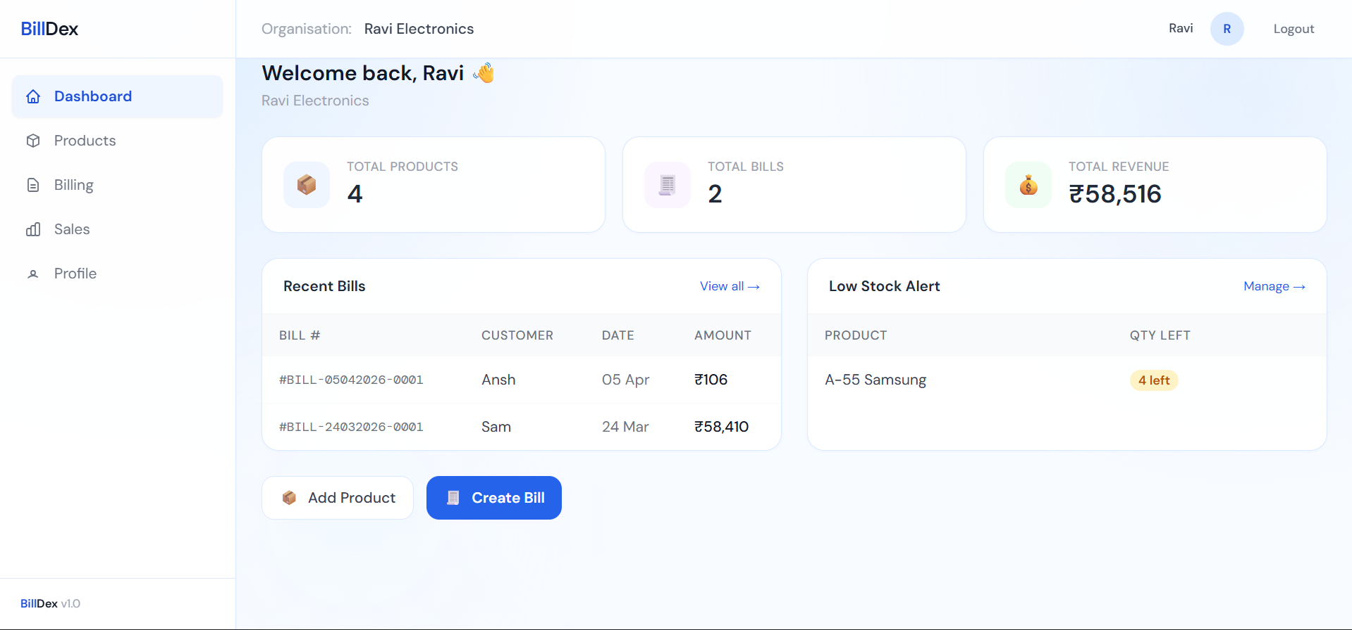

5.2 Products Page
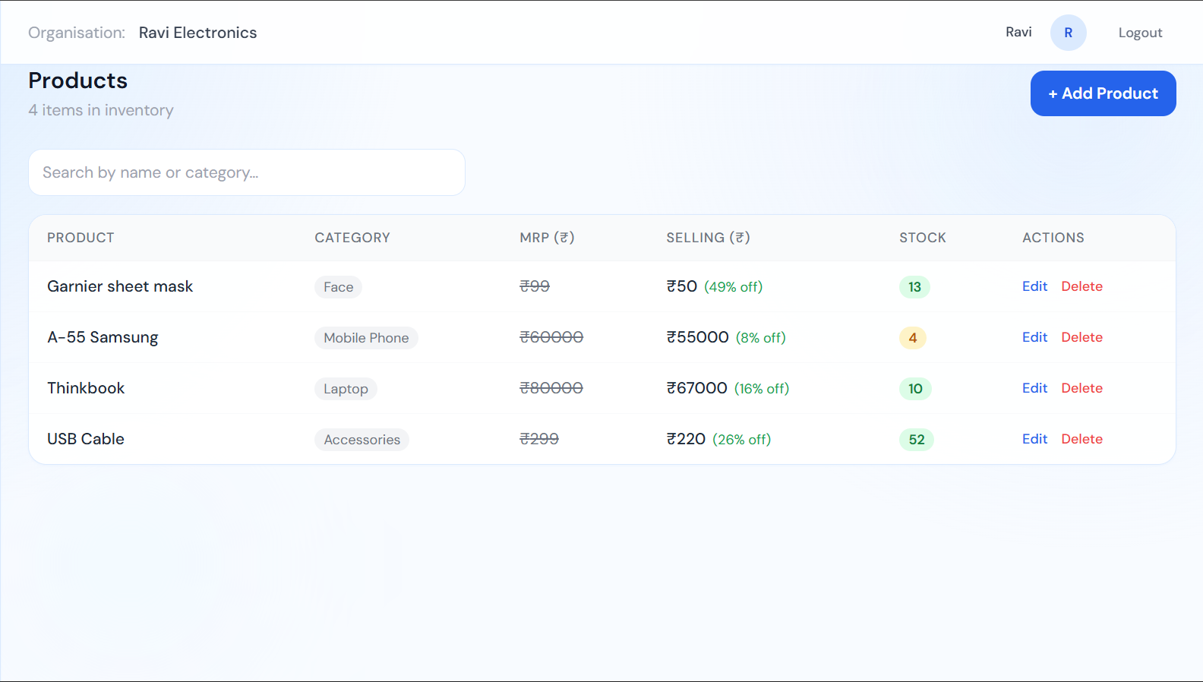

5.3 Billing Page
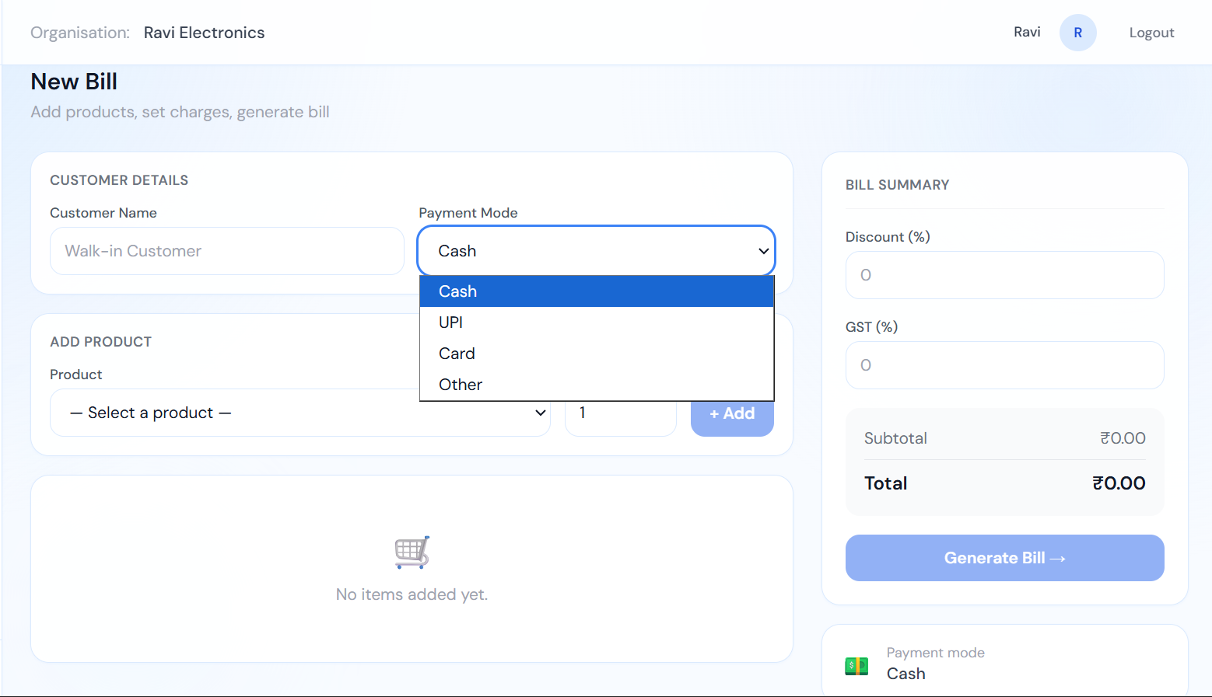

5.4 Sales History Page
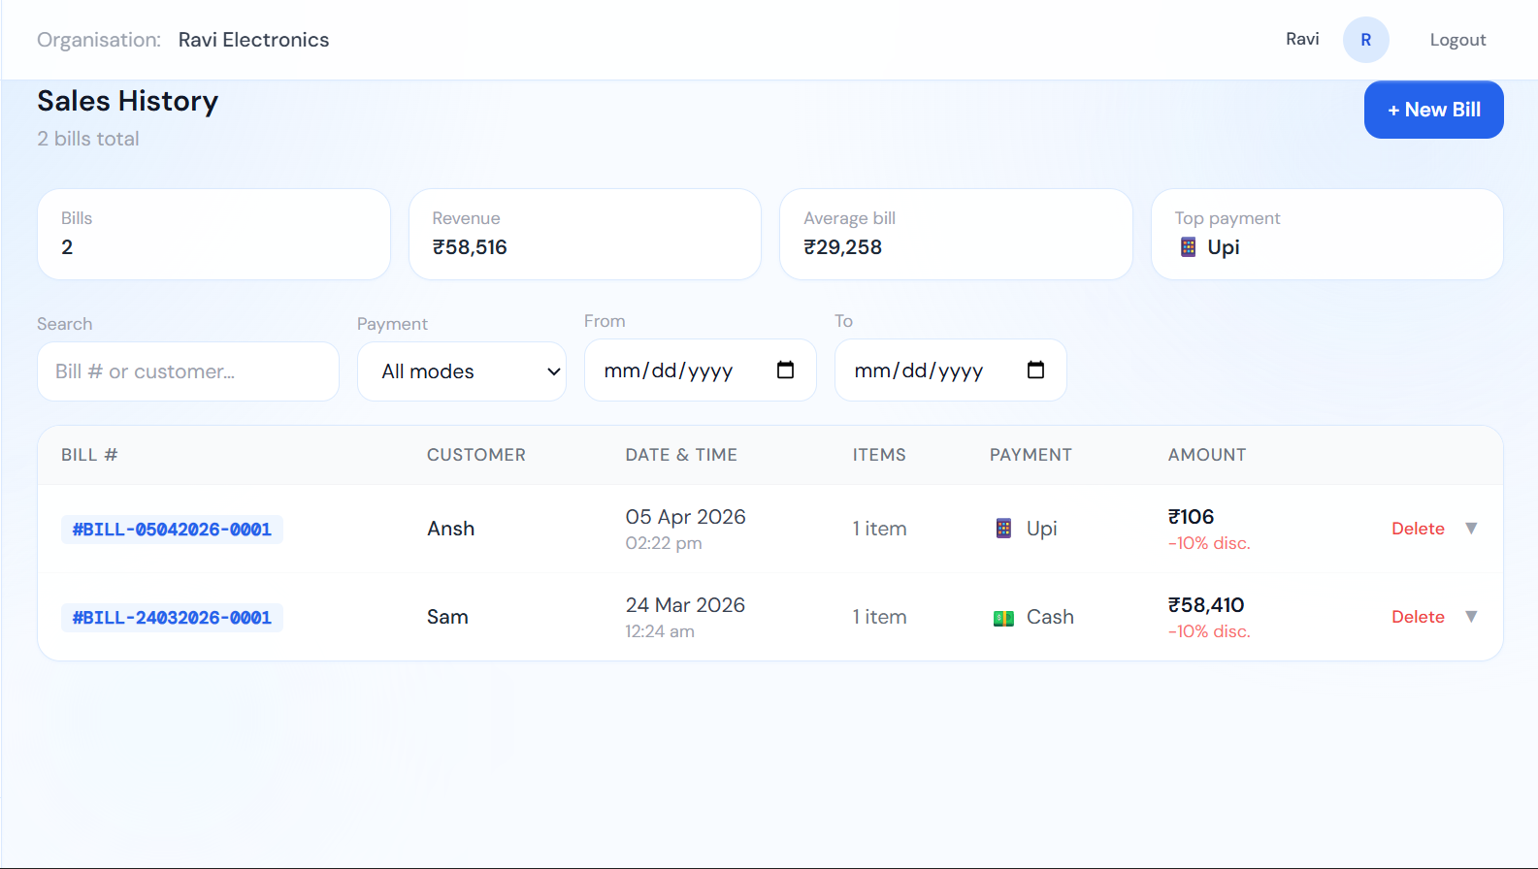
5.5 Home Page
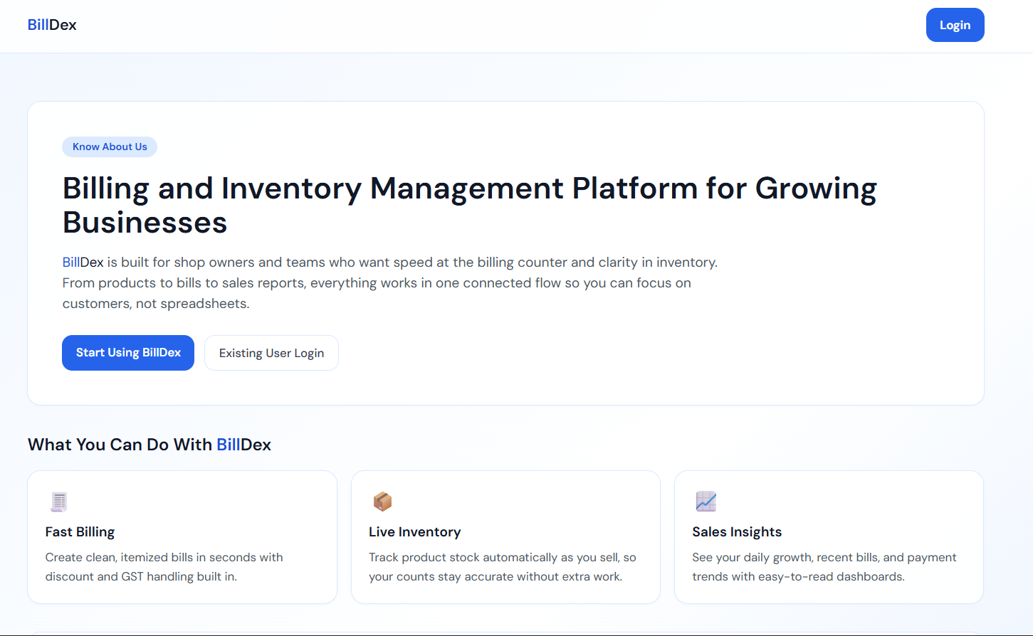

5.6 Login Page
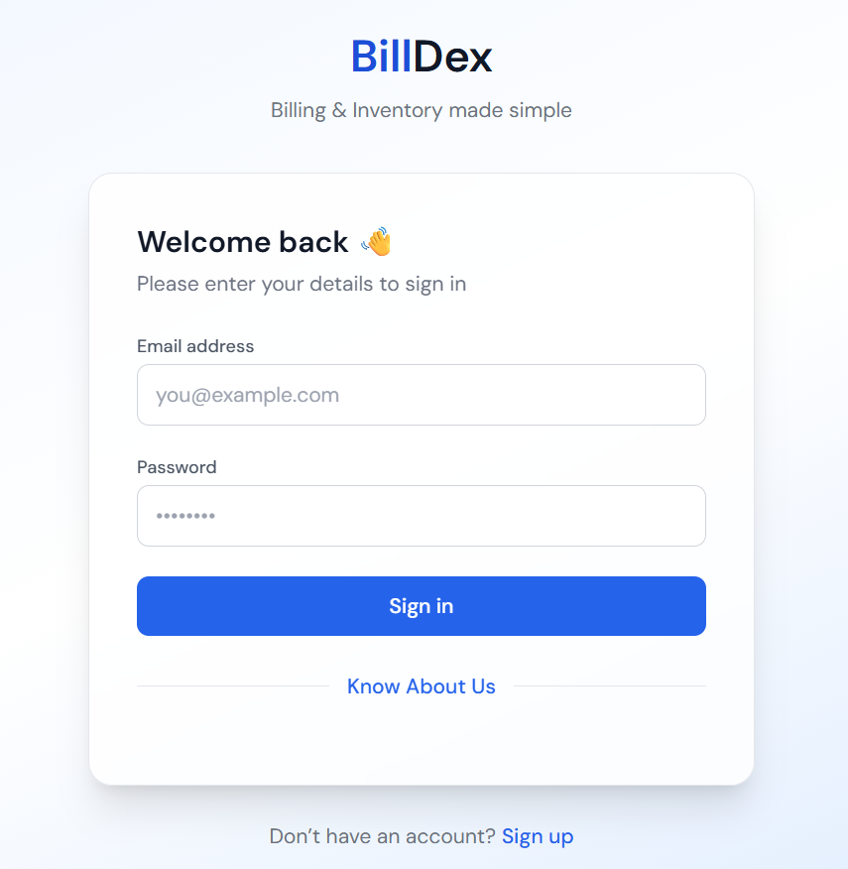

5.7 SignUp Page
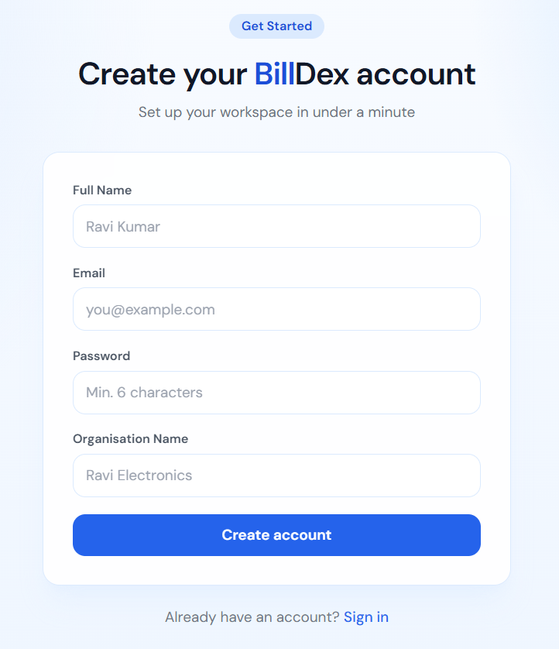
5.8 Profile Page
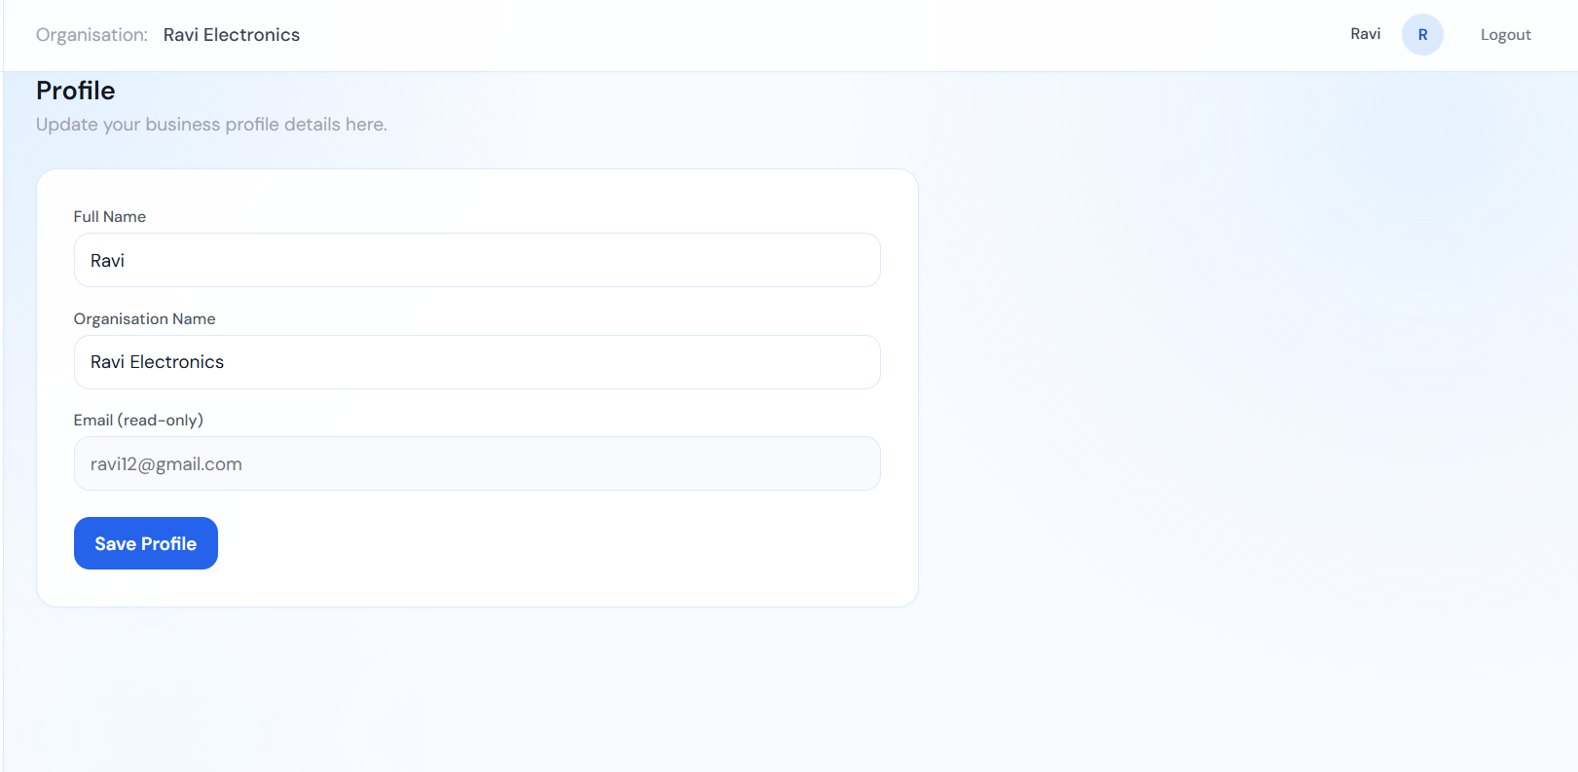
- Conclusion & Future Scope
Billdex is a modern and practical web-based billing and inventory management system developed to improve the efficiency of small and medium-scale businesses. The project successfully combines billing, product management, inventory tracking, and sales record maintenance into one centralized platform. By replacing manual processes with a digital solution, Billdex reduces errors, saves time, and helps businesses operate in a more organized manner. Its secure multi-user structure and user-friendly dashboard make it suitable for real-world business environments.

Key Achievements:
- Automated Billing System: Simplifies invoice generation with discount and GST support.
- Inventory Management: Automatically updates stock after each transaction.
- Sales Records: Maintains billing history for tracking and future reference.
- Secure Access: JWT-based authentication ensures safe user login and data privacy.
- Scalable Architecture: MERN stack enables future growth and feature expansion.
Billdex demonstrates how modern web technologies can solve common operational problems faced by local businesses while remaining affordable and easy to use.

Future Scope:
- Advanced Analytics Dashboard: Charts for sales trends, revenue growth, and product performance.
- Invoice Export & Printing: PDF bill generation and printer support.
- Low Stock Alerts: Notifications for products nearing minimum quantity.
- Search & Filters: Faster product and bill history management.
- Barcode Scanner Integration: Quick product billing and inventory updates.
- Role-Based Staff Accounts: Separate access for owner, manager, and cashier.
- Cloud Deployment: Secure anytime access from any location.
- Mobile Application: Android/iOS app for portable business management.
With future enhancements, Billdex has the potential to grow into a complete and scalable smart business management solution.

- References

- MongoDB Documentation – MongoDB, Inc. (2026). Official MongoDB Documentation for database design, queries, and data management.

- Express.js Documentation – Express.js Foundation. (2026). Official Express.js framework documentation for backend routing and API development.

- React Documentation – React Team. (2026). Official React.js documentation for building dynamic and responsive user interfaces.

- Node.js Documentation – OpenJS Foundation. (2026). Official Node.js documentation for server-side runtime environment and backend operations.

- Tailwind CSS Documentation – Tailwind Labs. (2026). Official Tailwind CSS documentation for utility-first frontend styling and responsive design.

- Mongoose Documentation – Mongoose Team. (2026). Official Mongoose ODM documentation for MongoDB schema modeling and database integration.

